Assignment 5-B

PRN:2018BTECS00045

Problem Statement 1: Design and develop a static web page using HTML for Android blog. Access it locally and in LAN using web server.

Answer:

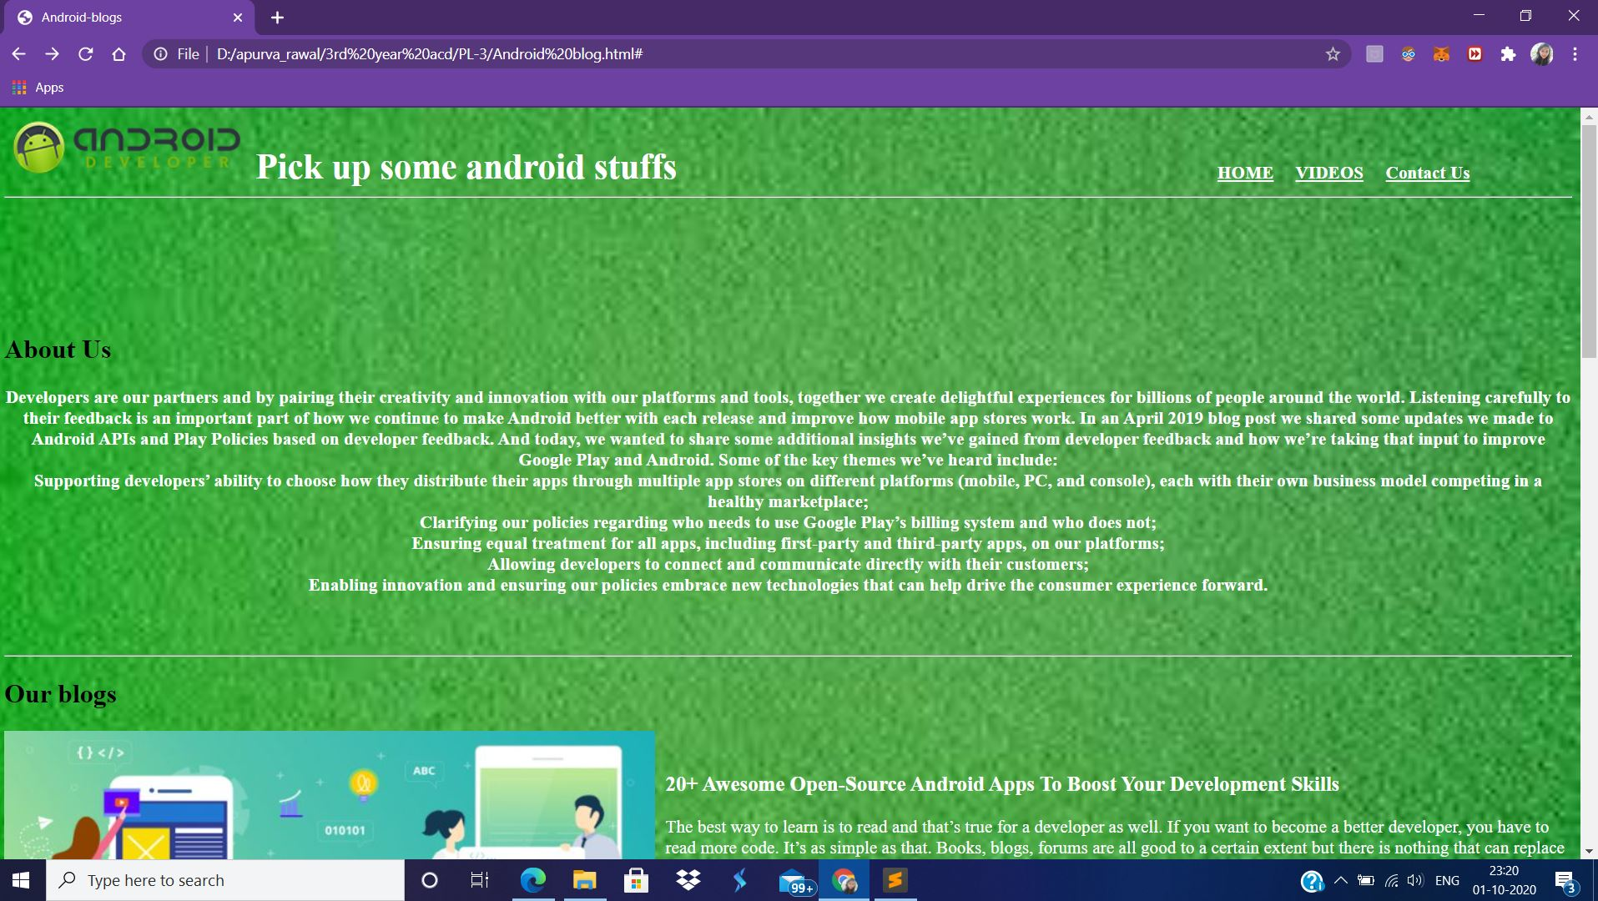

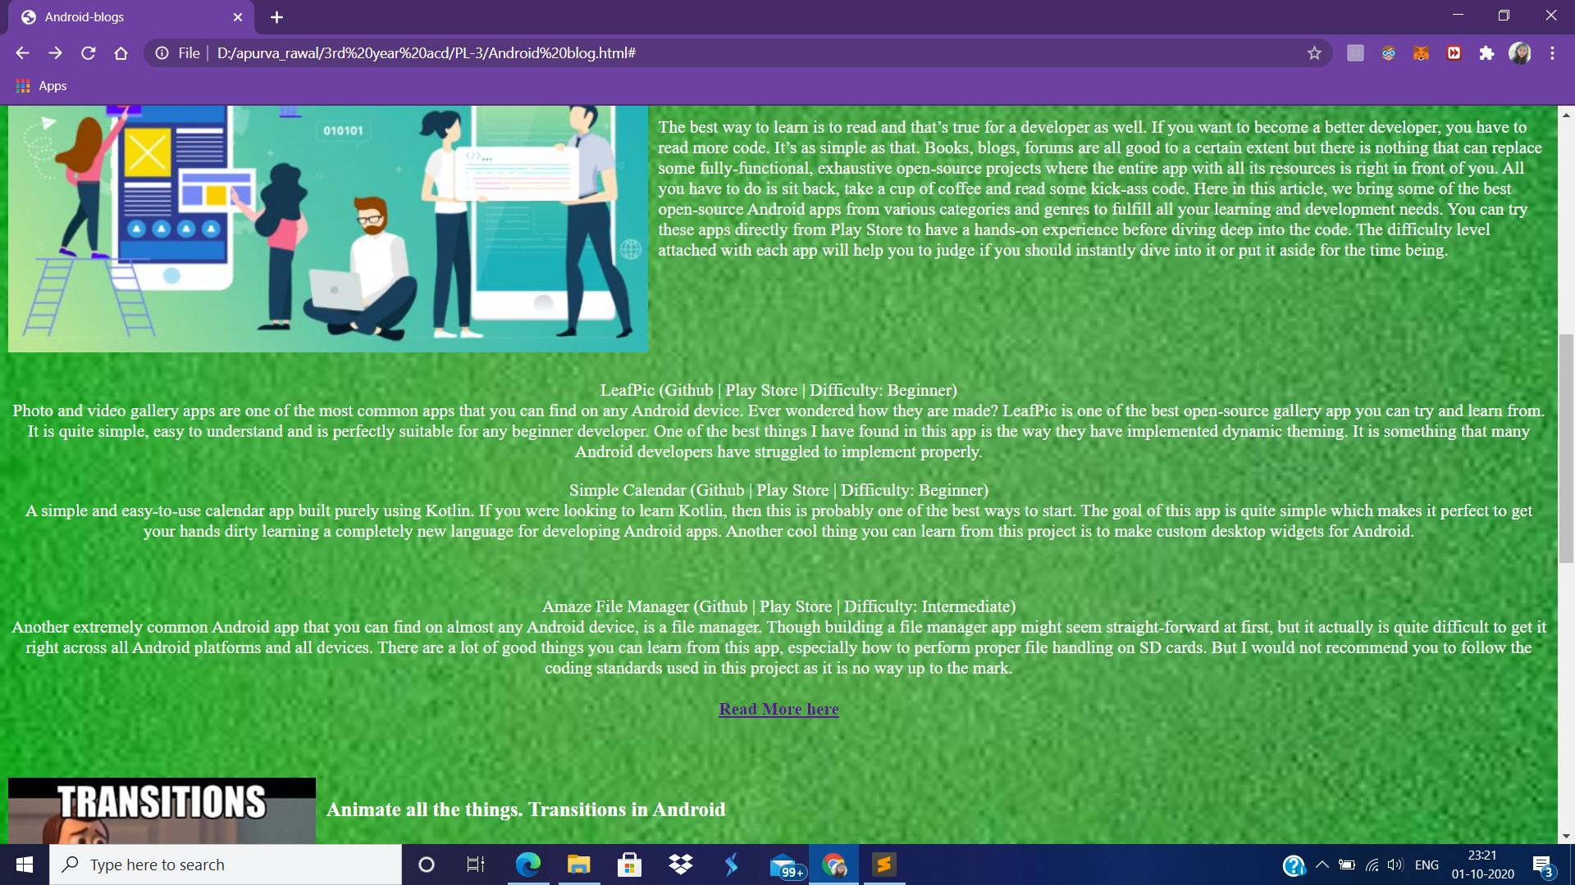

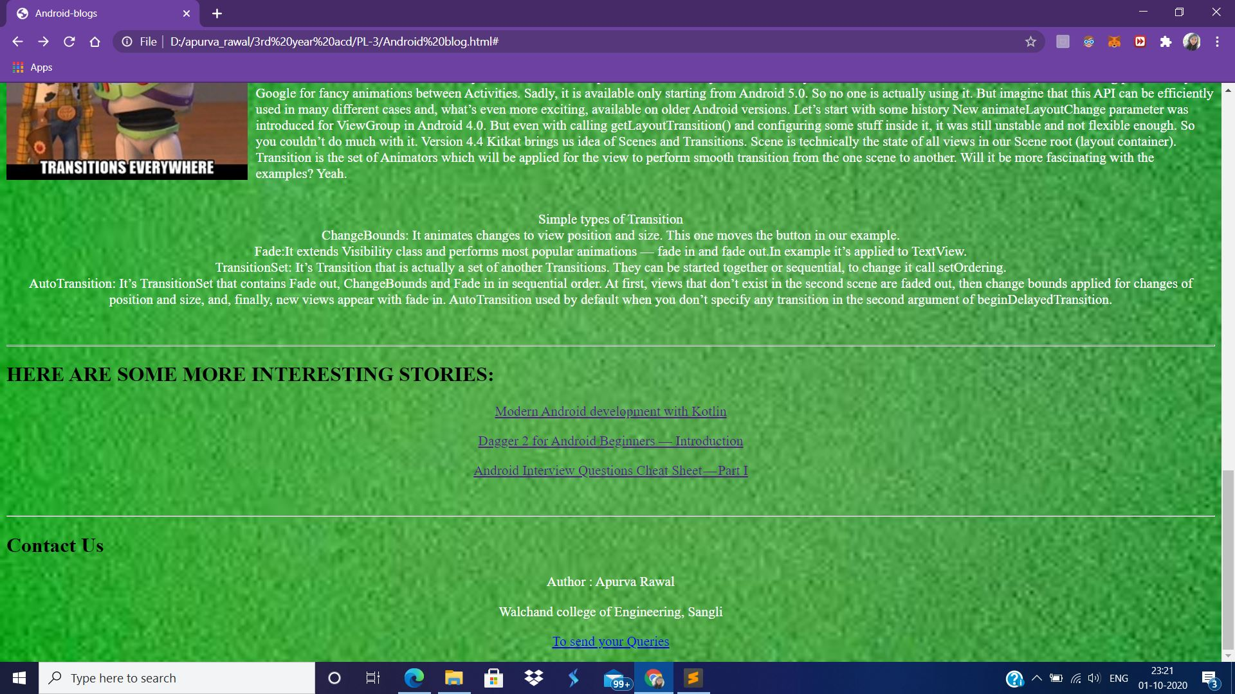

Problem Statement 2: Design and develop a static web page using HTML for following requirement. Access it locally and in LAN using web server. It should have following sections:

1. Problem Statement: Write a program in any language to find the maximum and minimum element in an array.

2. Code

3. Sample Input

4. Sample Output

5. Variables used in the program

6. Complexity

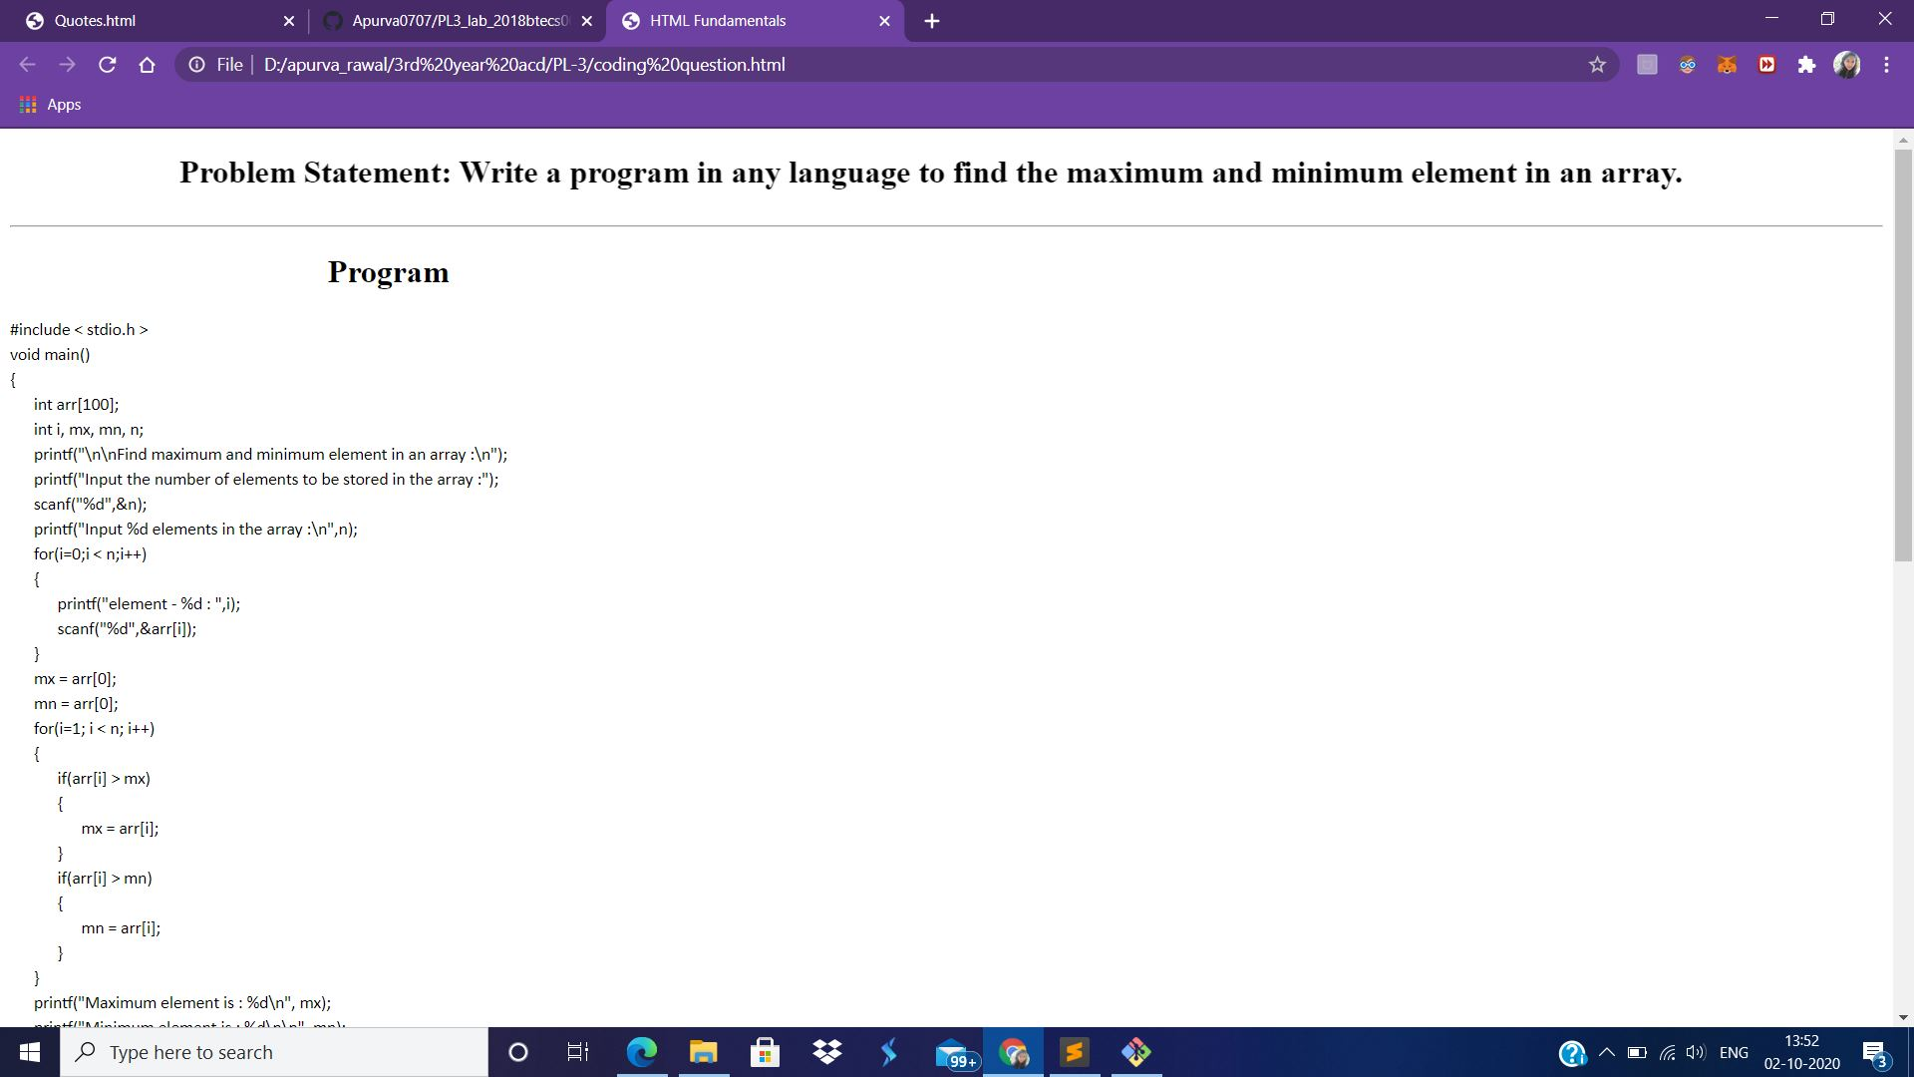

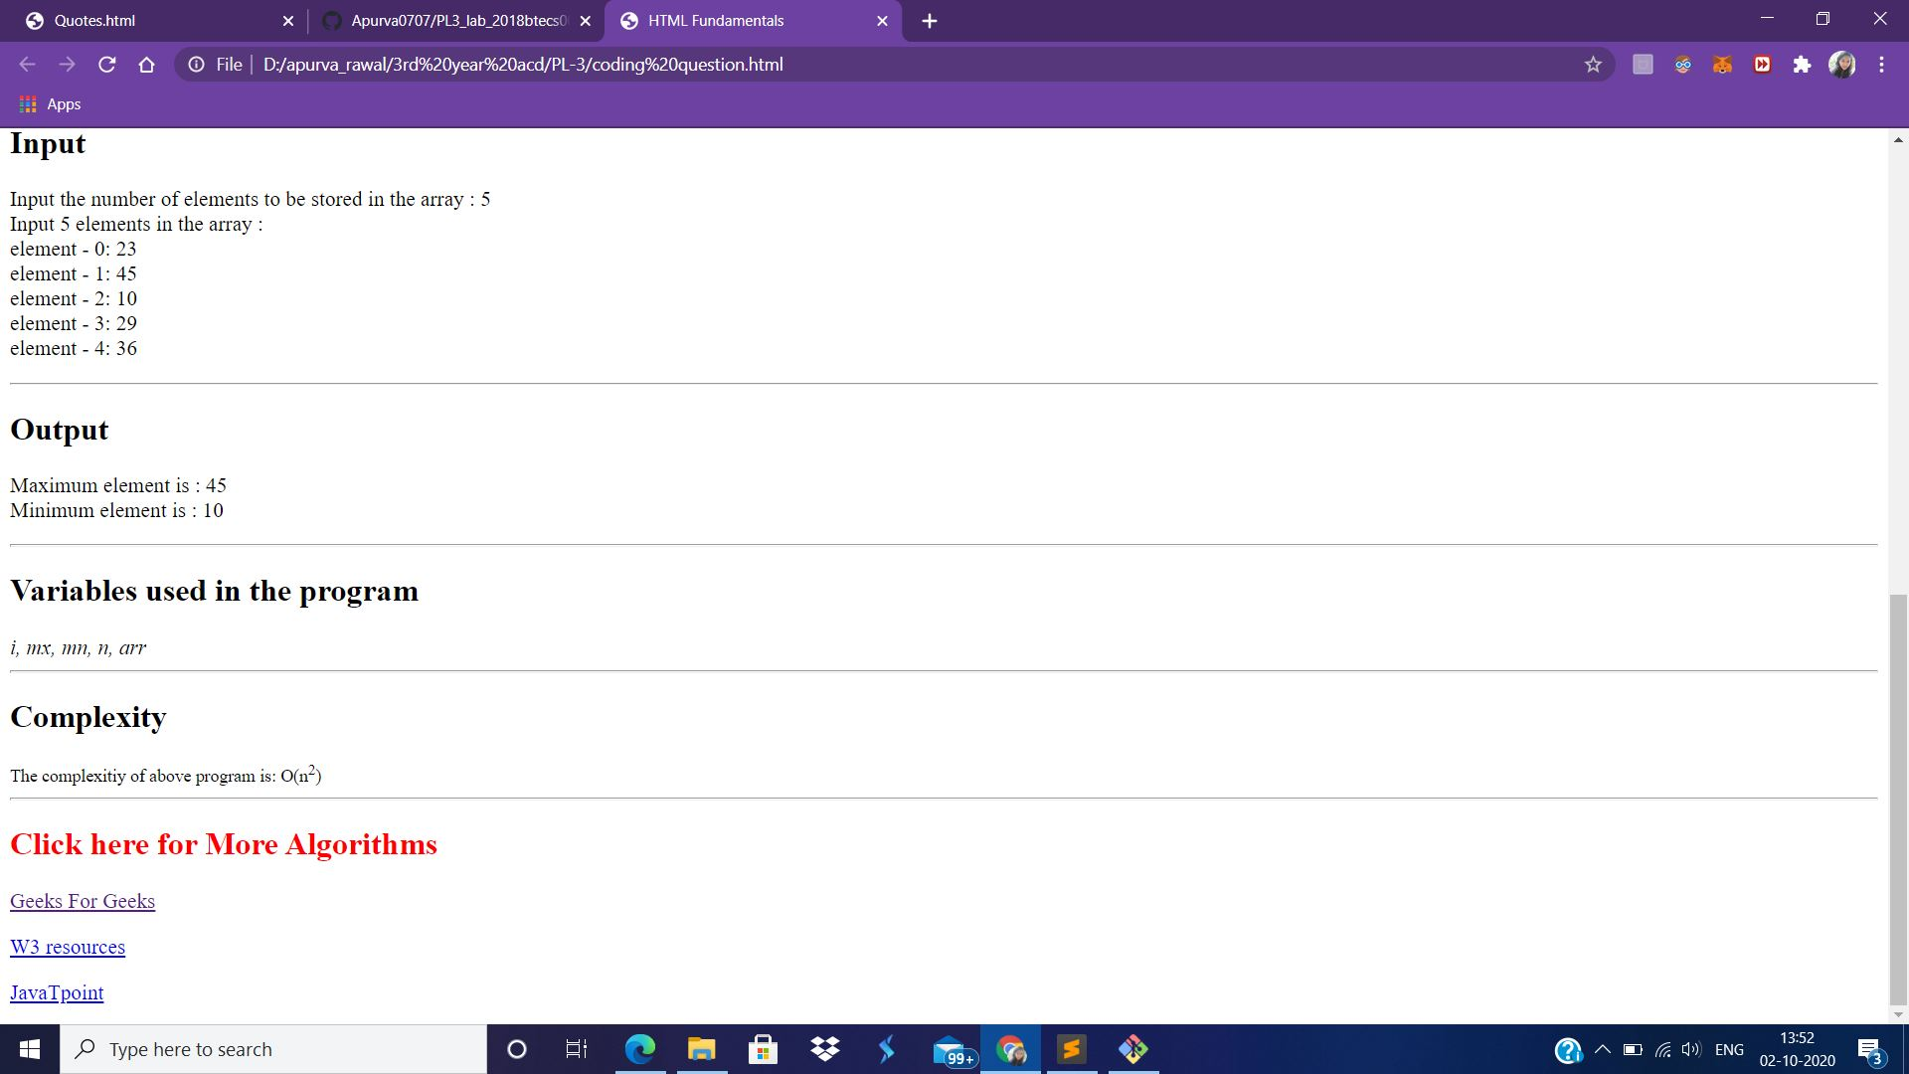

Problem statement 3: Design and develop a static web page using HTML for following requirement. Access it locally and in LAN using web server. It should have following sections: 1. Any three quotes from https://www.brainyquote.com/ with the name of person who quoted it

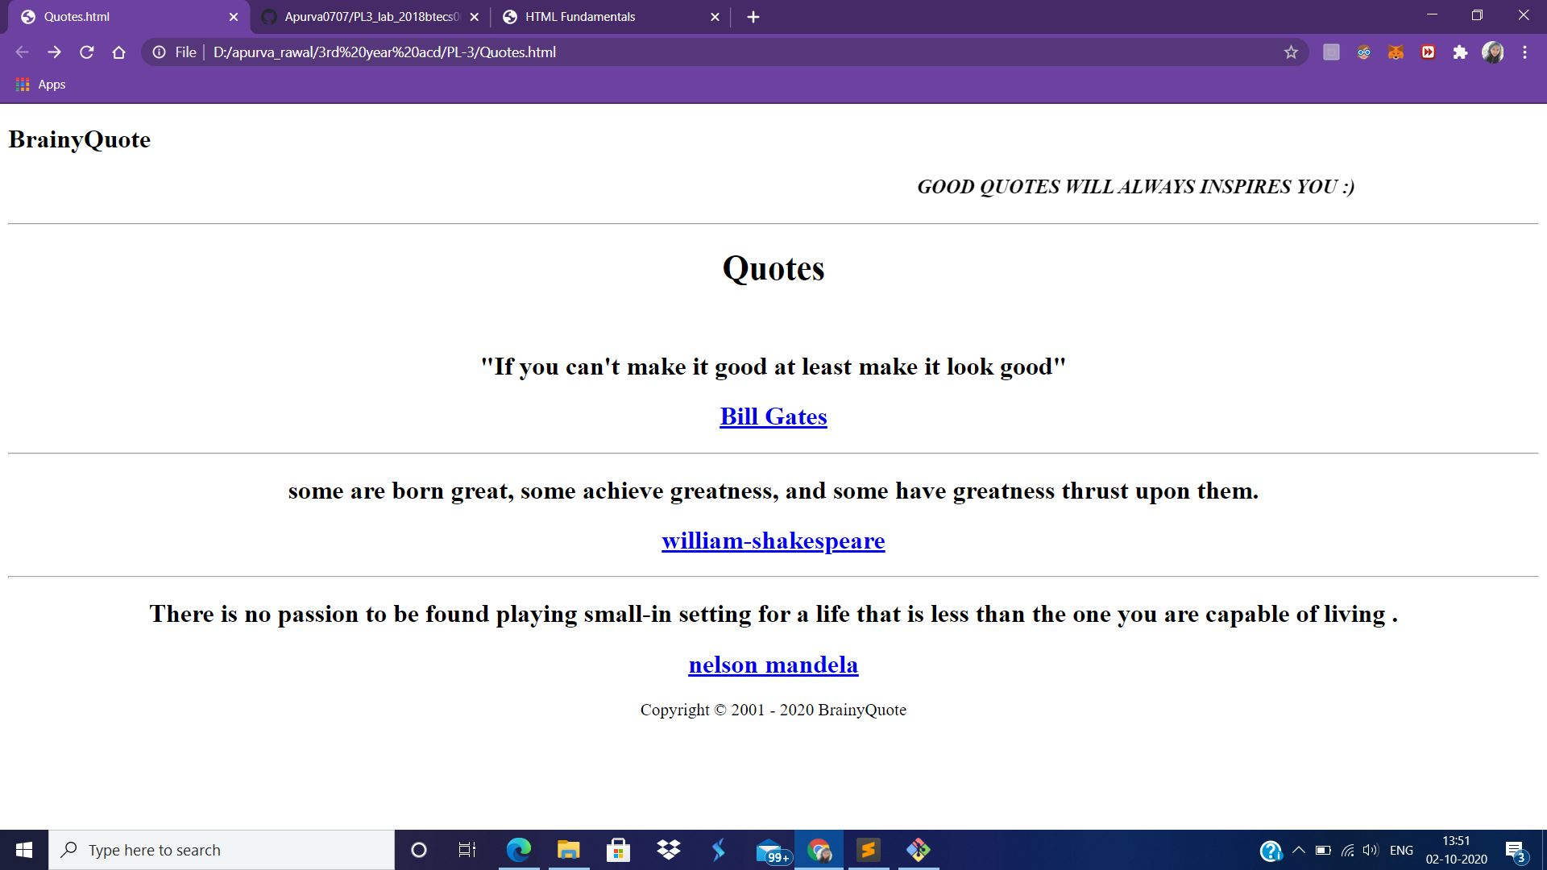

Repository link - <https://github.com/Apurva0707/PL3_lab_2018btecs00045>